Q1:

<!doctype html>

<html lang="en">

<head>

<title>Title</title>

<!-- Required meta tags -->

<meta charset="utf-8">

<meta name="viewport" content="width=device-width, initial-scale=1, shrink-to-fit=no">

<!-- Bootstrap CSS -->

<link rel="stylesheet" href="https://stackpath.bootstrapcdn.com/bootstrap/4.3.1/css/bootstrap.min.css" integrity="sha384-ggOyR0iXCbMQv3Xipma34MD+dH/1fQ784/j6cY/iJTQUOhcWr7x9JvoRxT2MZw1T" crossorigin="anonymous">

</head>

<body>

<div class="alert alert-primary alert-dismissible">

<button type="button" class="close" data-dismiss="alert">&times;</button>

<strong>Success!</strong> Indicates a successful or positive action.

</div>

<div class="alert alert-success alert-dismissible">

<button type="button" class="close" data-dismiss="alert">&times;</button>

<strong>Success!</strong> Indicates a successful or positive action.

</div>

<div class="alert alert-info alert-dismissible">

<button type="button" class="close" data-dismiss="alert">&times;</button>

<strong>Success!</strong> Indicates a successful or positive action.

</div>

<div class="alert alert-success alert-dismissible">

<button type="button" class="close" data-dismiss="alert">&times;</button>

<strong>Success!</strong> Indicates a successful or positive action.

</div>

<div class="alert alert-warning alert-dismissible">

<button type="button" class="close" data-dismiss="alert">&times;</button>

<strong>Success!</strong> Indicates a successful or positive action.

</div>

<div class="alert alert-danger alert-dismissible">

<button type="button" class="close" data-dismiss="alert">&times;</button>

<strong>Success!</strong> Indicates a successful or positive action.

</div>

<!-- Optional JavaScript -->

<!-- jQuery first, then Popper.js, then Bootstrap JS -->

<script src="https://code.jquery.com/jquery-3.3.1.slim.min.js" integrity="sha384-q8i/X+965DzO0rT7abK41JStQIAqVgRVzpbzo5smXKp4YfRvH+8abtTE1Pi6jizo" crossorigin="anonymous"></script>

<script src="https://cdnjs.cloudflare.com/ajax/libs/popper.js/1.14.7/umd/popper.min.js" integrity="sha384-UO2eT0CpHqdSJQ6hJty5KVphtPhzWj9WO1clHTMGa3JDZwrnQq4sF86dIHNDz0W1" crossorigin="anonymous"></script>

<script src="https://stackpath.bootstrapcdn.com/bootstrap/4.3.1/js/bootstrap.min.js" integrity="sha384-JjSmVgyd0p3pXB1rRibZUAYoIIy6OrQ6VrjIEaFf/nJGzIxFDsf4x0xIM+B07jRM" crossorigin="anonymous"></script>

</body>

</html>  
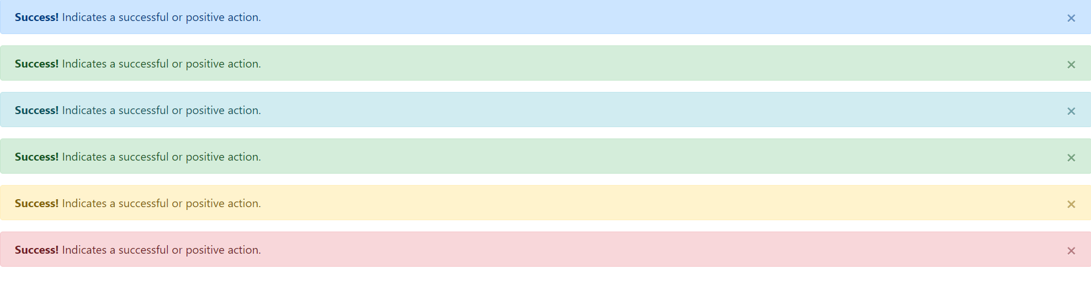

Q2:

<!DOCTYPE html>

<html lang="en">

<head>

<meta charset="UTF-8">

<meta name="viewport" content="width=device-width, initial-scale=1.0">

<title>Multiplication Table</title>

</head>

<body>

<h2>Multiplication Table</h2>

<script>

// Prompt the user to enter a number

var number = prompt("Enter a number:");

// Parse the input as an integer

number = parseInt(number);

// Check if the input is a valid number

if (!isNaN(number)) {

// Display the table

document.write("<p>Multiplication Table for " + number + ":</p>");

document.write("<ul>");

for (var i = 1; i <= 10; i++) {

document.write("<li>" + number + " \* " + i + " = " + (number \* i) + "</li>");

}

document.write("</ul>");

} else {

// Display an error message if the input is not a number

document.write("<p>Please enter a valid number.</p>");

}

</script>

</body>

</html>

